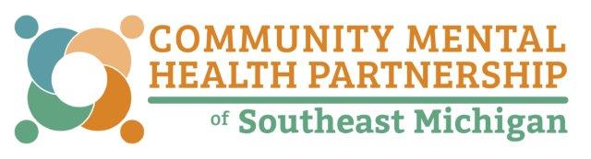

FY18 Direct Care Aide Level Wage Increase Attestation Form

The State of Michigan earmarked funding within the FY18 State Budget specifically to increase the wages of direct care aide level workers in Michigan by $0.50 per hour effective October 1, 2017.

Please print your name, sign, and date below:

I, confirm my hourly wage for hours worked on or after October 1, 2017 has been increased by ($0.50) fifty-cents per hour from my hourly wage on September 30, 2017.
Please contact your local Community Mental Health Service Program with any questions related to your wage increase.

Employee Signature Date

Employer Representative Signature Date

