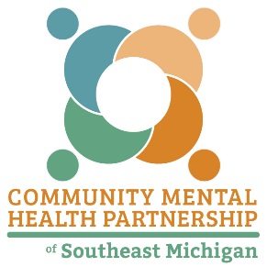

Lenawee

Livingston

Monroe

Washtenaw

SUD PREVENTION & TREATMENT SERVICES

media campaign request

MEDIA CAMPAIGNS

A media campaign, very broadly, is a message or series of messages conveyed through mass media channels including print, broadcast, and electronic media (i.e., billboards, PSAs, bus panels). Messages regarding the availability of services in the PIHP region are not considered to be media campaigns. Media campaigns must be compatible with Michigan Department of Health and Human Services’ (MDHHS) values, be coordinated with MDHHS campaigns whenever feasible and costs must be proportionate to likely outcomes. Prior written approval from MDHHS is required.

Provider: | Date:
Contact Person, Email, Phone:

Mass Media Campaign Name:

Type of Mass Media Mechanism to be Reviewed and Associated Cost:

Target Message:

Target Audience:

Target Community:

Targeted Outcome:

Please attach the actual media message, method, PSA script, etc., where applicable.

